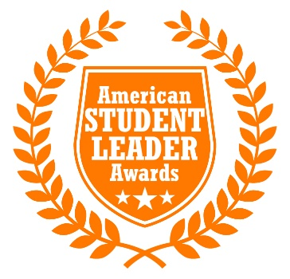
Greek Man/Woman of the Year
Since 1825, all but three U.S. presidents have been members of a fraternity.
85% of Fortune 500 executives were part of Greek life. The first female astronaut was Greek, as was the first female senator. College graduation rates are 20% higher among Greeks than non-Greeks. (USA Today, College Edition, 5/8/12).

Unfortunately, more often than not, collegiate fraternities and sororities are often associated with hazing, drinking, partying and other negative behaviors. At LEAD EVERYWHERE, we recognize that the over 9 million collegiate Greek members embody so much more than that.

They provide unique and valuable opportunities to develop leadership, networking skills, and enhance communities through service and philanthropy through lifelong bonds. As change agents. they are not only popular but influential on campuses and communities nationwide. On behalf of those change agents LEAD EVERYWHERE is proud to award Greek leadership in the following categories:

Fraternity and Sorority Life is about balancing academic excellence, service/philanthropy and leadership. Our Greek Man/Woman of the Year celebrates this balance with an infusion is creativity, inclusivity and uniqueness that distinguishes them above and beyond their peers. To qualify for this award the student leader must be an undergraduate member who has served in their organization for at least one academic year and is currently enrolled as a full time student.

This award exemplifies these qualities through initiating innovative programming and serving as a leader intra-council (amongst chapters in their respective council) and inter-council (amongst chapters in other councils).

Additionally they will exhibit the following qualifications/qualities for eligibility:
• Must have at least a 3.0 minimum GPA on a 4.0 GPA scale (or functional equivalent at your institution)
• The chapter should be currently active and in good standing with their respective host institution and national organization
• Civility towards others
• Cultural sensitivity and inclusiveness through their actions
• School pride and spirit that is displayed through teamwork among all students
• Integrity and accountability

Applicants will answer the following essay questions:
1. Share an educational program that you initiated or lead on your campus that exemplifies your creativity and uniquely impacted the community?

2. How have you initiated a more inclusive/diverse interaction with councils other than your own?

3. Name one instance in your collegiate career that you utilized your fraternal values to overcome personal or family challenges.

4. Have you held any leadership positions outside of Greek life in other student organizations?

5. Share an example of how you went above and beyond to assist/support others in need.

6. What are some other accomplishments that you would like to share with the committee that you think are relevant to Greek Man/Woman of the Year?

